Date | 26 JUNE 2026
Team ID
Project Name | Sports Hall Booking System using ServiceNow
Maximum Marks | 2 Marks

Problem – Solution Fit Template:
The Problem–Solution Fit validates that the Sports Hall Booking System using ServiceNow addresses the real challenges faced by students, faculty, and staff during sports hall reservations. The system replaces manual booking with an online reservation process, provides real-time hall availability, automated approval workflows, booking history, and instant notifications, resulting in a faster, more reliable, and user-friendly booking experience.
Purpose:
☐ Validate that the proposed solution addresses the real problems faced by students, faculty, and sports administrators.
☐ Improve the booking experience by providing real-time hall availability and online reservation facilities.
☐ Reduce duplicate bookings, manual paperwork, and approval delays through workflow automation.
☐ Increase transparency and efficiency by maintaining centralized booking records and notifications.
☐ Ensure the solution meets user expectations and supports a reliable, secure, and scalable booking process.

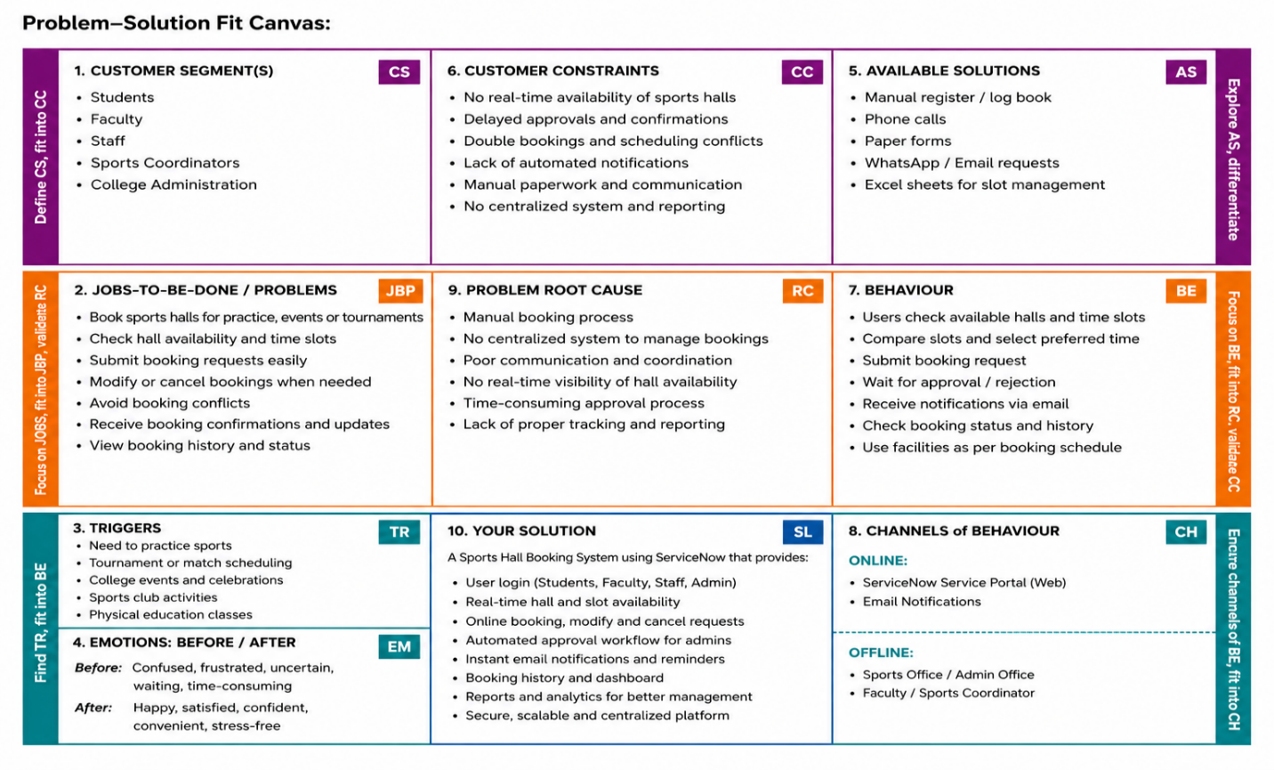

References :
1. ServiceNow Official Website - https://www.servicenow.com/
2. ServiceNow App Engine - https://www.servicenow.com/products/app -engine.html
3. ServiceNow Documentation - https://www.servicenow.com/docs/

